

**NET320-Database Systems**

**SWS213-Database Design**

**Spring ‘17**

**Lab 4- Class Assignment 1**

**Lab 4**

**Objective**

Upon successful completion of this lab the student will be able to:

* Create schemas and tables.
* Datatypes
* Use of basic SQL commands

**Grading Scheme**

* This class assignment is due on 20 February 2018 at 6:00 PM.
* Students should save the Workbench file and upload to moodle.
* Save the file with your Name followed by ID.
  + Task 1 - 5 pts
  + Task 2 - 5 pts

**Back ground**

* Students should be familiar with the Workbench.
* Before starting the lab, make sure MySQL is running.

**Task 1**

1. Create a Schema named Entertainments.
2. Create a table called ‘Parks’ that contains the below details.

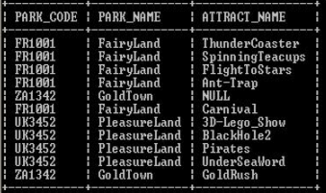

1. The model should save as PARKS_Lab4’.
2. A live database server should be assigned and name it as ‘Park_Server’.
3. Give inputs for the various columns from the above table.

**Task 2 (Take a screen shot of the queries with their output)**

1. What is the query to display all the details of the Parks.
2. What is the query to display all the details of the Park Name - FairyLand.
3. What is the query to display only the PARK_NAMES.
4. Display only the Park Name that has the attract name of Carnival.
5. Display the Park Name with park code- UK3452